Quantum Circuit Born Machine Assisted Fraud Detection in Financial Transactions

Abstract
Financial fraud continues to grow in scale and complexity, creating major challenges for financial institutions. Classical fraud detection systems rely on labelled fraud data, which is extremely limited and does not capture new or evolving attack strategies. This motivates the need for unsupervised methods capable of learning normal transaction behavior and identifying deviations.
In this work, we investigate the use of Quantum Circuit Born Machines (QCBMs) as a generative quantum model for anomaly detection. We evaluate two data representations: PCA-reduced 2D space and VAE-generated 2D latent space. Results show that QCBMs learn normal transaction distributions well and achieve high accuracy on small datasets with clear separation. However, on the full dataset, fraud heavily overlaps normal transactions, limiting anomaly detection performance. Our analysis highlights the importance of data representation in quantum anomaly detection and provides insight for hybrid quantum–classical fraud detection systems.
Keywords: quantum machine learning, QCBM, anomaly detection, fraud detection, PCA, VAE.

1. Introduction
Credit card fraud causes billions of dollars in losses annually, affecting banks and consumers globally. Fraud patterns evolve rapidly, making supervised learning approaches ineffective because they depend on large amounts of labelled fraud data. Since fraud cases are rare and constantly changing, classical models often fail to detect new types of fraudulent behavior.
Quantum generative models may offer new ways to model complex probability distributions. A Quantum Circuit Born Machine (QCBM) is a parametrized quantum circuit capable of learning a probability distribution over measurement outcomes. This makes QCBMs suitable for unsupervised anomaly detection, where the goal is to learn the distribution of normal transactions and identify anomalies as low-probability events.
The objective of this research is to explore whether QCBMs can effectively learn normal transaction patterns and accurately detect anomalies. We compare PCA-based and VAE-based representations to evaluate how different feature spaces influence QCBM performance.

2. Dataset and Preprocessing
We use the Credit Card Fraud Detection Dataset, containing 284,807 transactions, with only 492 labeled as fraud. Because fraud represents less than 0.2% of the dataset, anomaly detection is extremely challenging.
2.1 Log Transformation
The “Amount” feature is heavily skewed; we apply:
$${\text{Amount}}_{\text{log}}=log⁡(1+\text{Amount})$$
2.2 PCA Reduction to 2D
We reduce the 29 numerical features to:
- PCA Component 1
- PCA Component 2
This allows the QCBM to learn a 2D probability map, later discretized into a 16×16 grid.
2.3 Normalization
Each component is scaled to $\left[0 , 1\right]$using min–max normalization.
2.4 2D Binning
We divide the normalized PCA space into 16×16 bins, producing 256 discrete states, matching the QCBM’s 8-qubit output space.
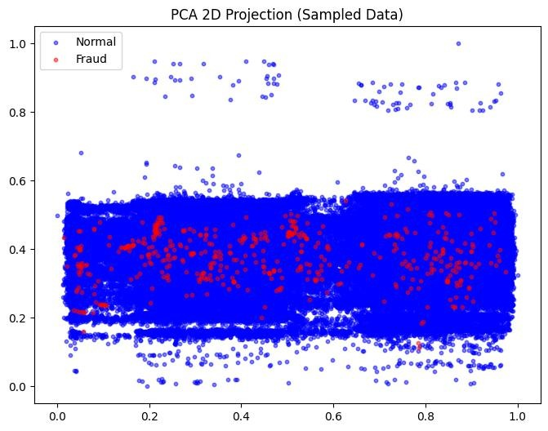
Figure 1. PCA Sample Comparison

3. QCBM Architecture
The QCBM used in this study consists of:
- 8 qubits
- 8 repeated layers (ansatz depth)
- Ry rotation gates on each qubit
- Circular CNOT entanglement, connecting q0→q1→…→q7→q0
- 64 trainable parameters (8 per layer × 8 layers)
The measurement outputs a distribution over the $2^{8}=256$computational basis states, corresponding to the 16×16 bin representation.

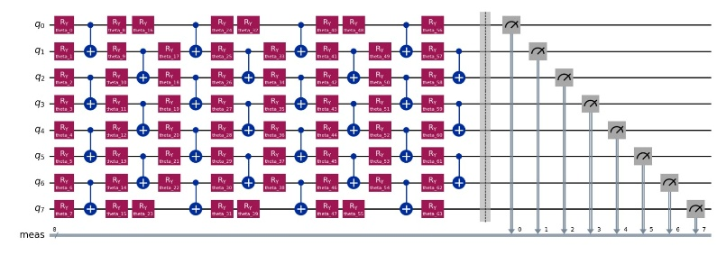Figure 2. QCBM Circuit Diagram

4. Mathematical Model
The QCBM defines a probability amplitude through a parametrized quantum circuit.
4.1 Initial State
$$∣ψ_{0}⟩=∣0⟩^{⊗8}$$
4.2 Rotation Layer
$$U_{\text{rot}}(θ^{\left(l\right)})=\overset{7}{\underset{i=0}{⨂}}R_{Y}(θ_{i}^{\left(l\right)})$$
4.3 Entanglement Layer (Circular)
$$U_{\text{ent}}=\prod_{i=0}^{7}{CNOT}(q_{i},q_{(i+1) mod 8})$$
4.4 Layer Composition
$$U_{\text{layer}}(θ^{\left(l\right)})=U_{\text{ent}}⋅U_{\text{rot}}(θ^{\left(l\right)})$$
4.5 Full Circuit
$$U(θ)=\prod_{l=1}^{8}{U_{\text{layer}}}(θ^{\left(l\right)})$$
4.6 Output Distribution
$$p_{θ}(x)=∣⟨x∣U(θ)∣ψ_{0}⟩∣^{2}$$

5. Cost Function and Optimization
To train the QCBM, we minimize a hybrid divergence between target distribution $p_{\text{data}}$and QCBM output $p_{θ}$:
$$C(θ)=\text{JSD}(p_{θ},p_{\text{data}})+\text{KL}(p_{\text{data}}∥p_{θ})$$
- Jensen–Shannon Divergence stabilizes training.
- KL Divergence penalizes missing probability mass.
Optimizers used:
- COBYLA (for 1D experiments)
- SPSA (for 2D experiments due to noise robustness)

6. PCA–QCBM Experiments
6.1 PCA Full Dataset Behavior
Fraud points lie inside the normal cluster, producing heavy overlap. QCBM struggles to classify anomalies because fraud is not separated in the feature space.
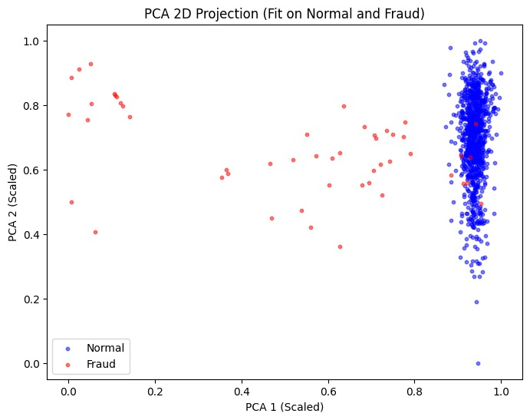
Figure 3. PCA Full Dataset

6.2 PCA Small Dataset Behavior
On small subsamples (≈1000 points), PCA reveals clear separation between fraud and normal, resulting in excellent QCBM detection performance.
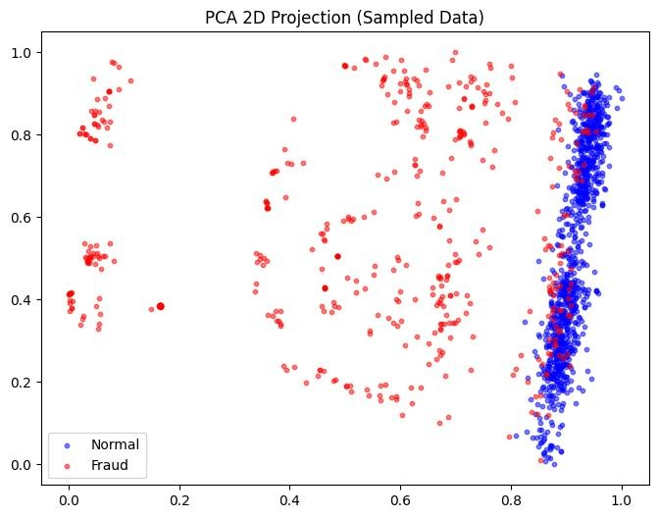
Figure 4. PCA Small Dataset

6.3 Target Distribution
Normal transactions binned into a 16×16 heatmap form the target training distribution.

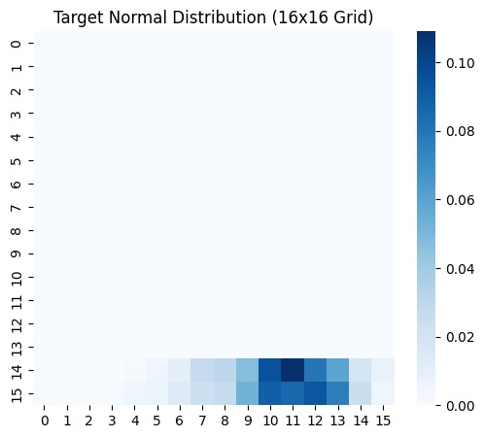
Figure 5. Target Normal Distribution Heatmap
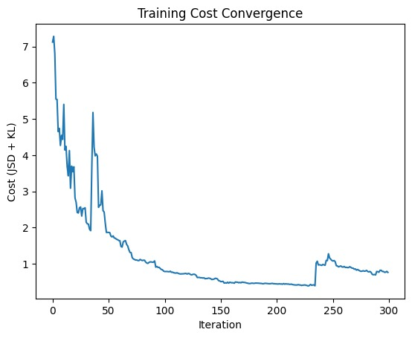
Figure 6. QCBM Training Cost Curve
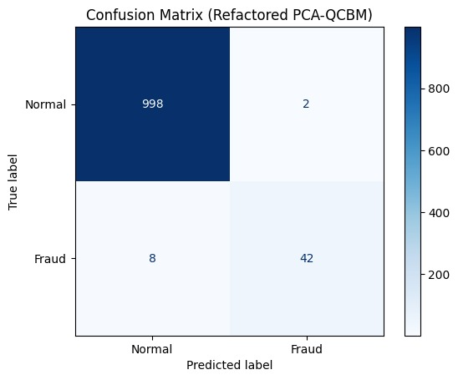
Figure 7. QCBM Confusion Matrix (Small Dataset)

7. VAE–QCBM Hybrid Experiments
7.1 VAE Training
The VAE is trained only on normal transactions. The reconstruction loss decreases steadily, showing that the model captures the distribution well.
7.2 Latent Space Analysis
Although the VAE compresses normal points into a tight region, many fraud points still fall inside this region. This means that even non-linear compression does not fully separate fraud.
7.3 QCBM on VAE Latent Space
The QCBM learns the latent distribution but fails to isolate fraud due to the same overlap problem inherited from the VAE.

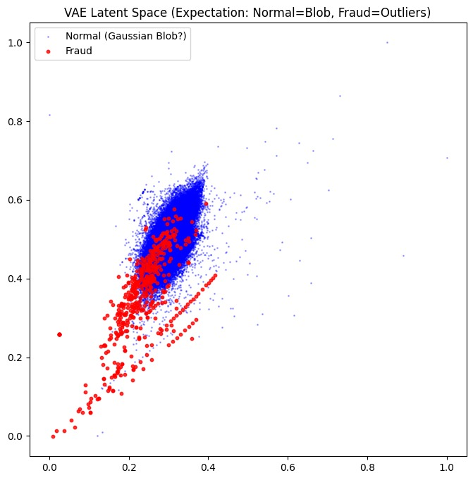Figure 8. VAE Latent Space Plot
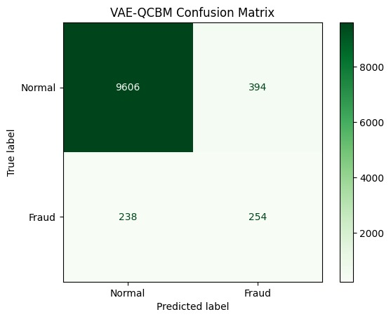
Figure 9. VAE–QCBM Confusion Matrix

8. Discussion
Our results show:
- QCBM performance directly depends on the quality of the data representation.
- When PCA or VAE produces clearer separation, QCBM performs extremely well.
- When fraud overlaps normal in PCA or VAE space, the QCBM is unable to detect anomalies effectively.
- This limitation comes not from the quantum model, but from the data itself.
- The hybrid VAE approach improves representation slightly but does not fully solve the overlap problem.

9. Conclusion and Future Work
Quantum Circuit Born Machines show strong potential for unsupervised anomaly detection when the underlying data representation exhibits separability. However, the full dataset shows heavy overlap between fraud and normal transactions, making anomaly detection difficult for both classical and quantum approaches.
Future work may include:
- Alternative feature extraction methods
- Different quantum encodings (amplitude, angle, high-dimensional embeddings)
- Deeper or more expressive circuits
- Hybrid classical quantum systems
- Testing models on real quantum hardware

References
[1] C. Zoufal, A. Lucchi, and S. Woerner, “Quantum generative models for learning probability distributions,” npj Quantum Information, vol. 5, 2019.
[2] R. Orús, S. Mugel, and E. Lizaso, “Applications of quantum computing in finance,” Reviews in Physics, vol. 4, 2019.
[3] O. Kyriienko and E. B. Magnusson, “Unsupervised quantum machine learning for anomaly and fraud detection,” arXiv preprint arXiv:2208.01203, 2022.
[4] K. Mitarai, M. Negoro, M. Kitagawa, and K. Fujii, “Quantum circuit learning: A framework for supervised and generative tasks,” Physical Review A, vol. 98, 2018.
[5] IBM Quantum, “Qiskit: Open-source framework for quantum programming,” [Online]. Available: https://qiskit.org/
[6] Kaggle, “Credit Card Fraud Detection Dataset,” [Online]. Available: https://www.kaggle.com/datasets/mlg-ulb/creditcardfraud
[7] J. Jurgovsky et al., “Credit-card fraud detection through sequence classification and representation learning,” Expert Systems with Applications, vol. 100, pp. 234–245, 2018.
[8] A. Ghahramani, “Probabilistic machine learning and anomaly detection,” Nature, vol. 521, pp. 452–459, 2015.
[9] Kingma, D. and Welling, M., “Auto-Encoding Variational Bayes,” arXiv preprint, arXiv:1312.6114, 2013.
[10] J. Amari, “Divergence measures and learning distributions,” Information Geometry & Machine Learning, Springer, 2016.

